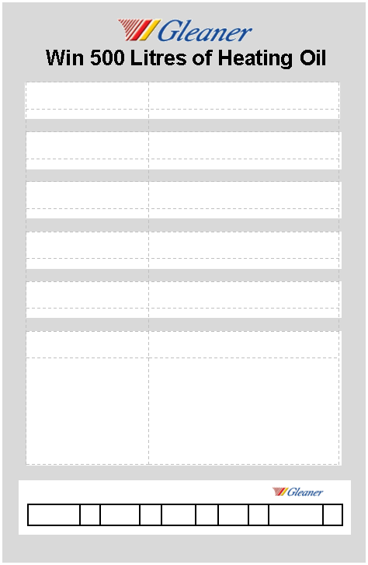

Lubricants

LPG

Diesel

Gas Oil

Kerosene

Product Requirements:

Address: Click here to enter text.

Email: Click here to enter text.

Telephone: Click here to enter text.

Surname: Click here to enter text.

First Name: Click here to enter text.

Title: Click here to enter text.